**SOLVEM Overview**

This is a problem-solving approach and is assigned the acronym SOLVEM.

**S**ketch

**O**bjectives or **O**bservations

**L**ist

**V**ariables

**E**quations

**M**anipulations.

This technique of problem solving is equivalently useful for difficulties involving estimations and more precise calculations. All the steps are described below.

**SKETCH:**

The Sketch illustrates, how the drawing of a problem helps you to visualize the problem. In sketching the situation, we are subconsciously thinking about it. One should be aware to draw the sketch large enough so that everything becomes clear and easy to think about. The labelling of the known things is also very important for a much clearer idea of the difficulty. In some situations, we can also make more then one diagram like the before-and-after set of diagrams. In very complex situations we can also make intermediate diagrams as well.

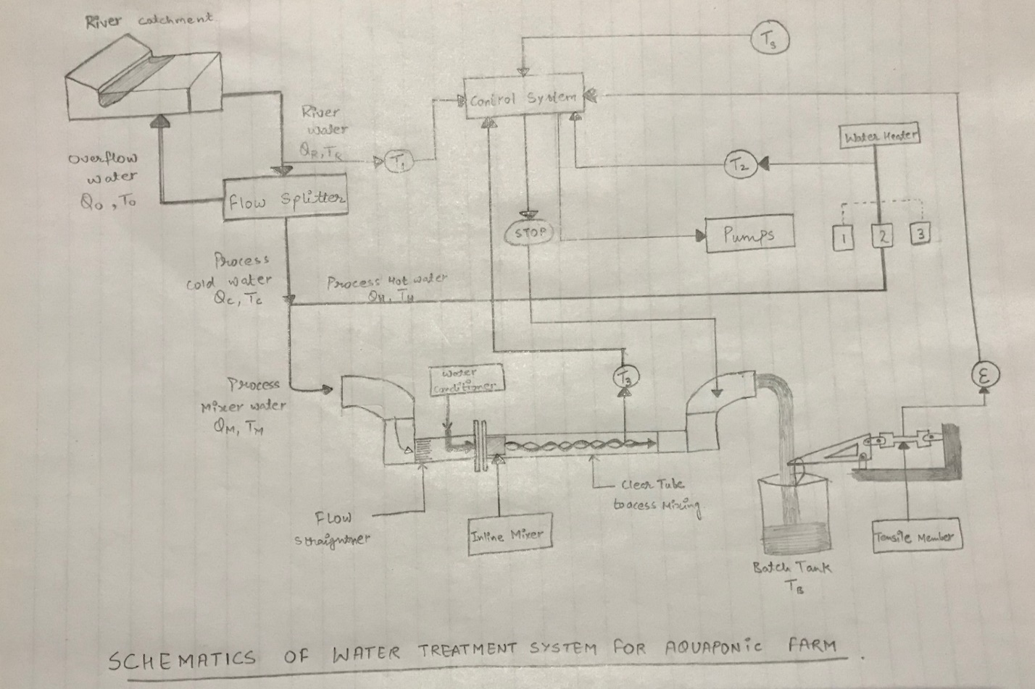

**Fig: SCHEMATICS OF WATER TREATMENT SYSTEM FOR AQUAPONIC FARM**

**OBJECTIVES, OBSERVATIONS:**

Objectives or Observations can be of the form of questions, simple statements or anything else that can make you familiar with the difficulty. This can also help in dividing the objectives and observations into different categories. Some of the most common things we can write are:

* Observations about the materials and their properties.
* Observations about the parameters like temperature and velocity which can’t be easily sketched.
* Objective about what needs to be achieved.
* Observations like size, shape and other geometry related problems.
* Several other diversified observations that are important as well.

Some of the typical examples of Observations and Objectives are:

**Objectives:**

* Build and demonstrate water treatment for a fish farm.
* Find the speed, distance, force, pressure, etc of flowing water.
* Fit the mixer and splitter into the right position.
* Calculating the resultant temperature of the water.
* Make a good co-ordinated control system.

**Observations:**

Observations can be:

* The river water ranges from 2-260C.
* The mass of Batch tank is 5Kg and volume is 12.5L.
* The set point temperature is in the range appropriate for tilapia fish.
* The pond water ranges from 27-310C.

While observations can also be related to materials and their properties like:

* The melting point of aluminium is 660.30C.
* Plastic will float on water.
* The value of gravity is 9.8 m/s2.
* Water boils at 100 degree Celsius.

**LIST OF VARIABLES AND CONSTANTS:**

In this part, we need to go over the observations section and then list all the variables that are important. The list can be divided into several broad categories such as those related to the geometry problems, the problems related to materials and their properties, and some problems comes under those categories that may not be appropriately defined is above mentioned categories. We need to include the name of the variable, the symbol; used to denote it, and the value of the variable (if known), including the units. The constants can also be listed. Some of the examples of different categories are highlighted below as per the sketch:

|  |  |  |
| --- | --- | --- |
| **Symbol** | **Variable** | **Units** |
| w | Tensile member gauge width | mm |
| T0 | Temp. of overflow water. | 0C |
| ε | Strain signal. | μ m/m |
| QM | Flow of mix process water. | L/min |
| TM | Temp. of mix process water. | 0C |
| TB | Batch Temperature. | 0C |
| TC | Temp. of cold process water | 0C |
| TH | Temp. of hot process water | 0C |
| TP | Temp. of fish ponds | 0C |
| TR | Temp. of river water | 0C |
| TS | Set point temperature. | 0C |
| Ti (I = 1,2,3) | Temp. of probe signals. | 0C |
| Lsg | Length of strain gauge | mm |
| mBT | Mass of batch tank | Kg |
| Qc | Flow of cold process water | L/ min |
| Qh | Flow of hot process water | L/ min |
| QM | Flow of mixed process water | L/ min |
| QO | Flow of overflow water | L/ min |
| QR | Flow of river water | L/ min |
| ρG | Density of glycerol | Kg/ L |
| ρW | Density of water | Kg/ L |
| μ g | Dynamic viscosity (glycerol) | Pa·s |
| μ w | Dynamic viscosity (water) | Pa·s |
| VB | Batch volume | L |
| VBT | Volume of batch tank | L |
| c | Specific heat | J/ Kg K |

**Some of the properties we can think about are:**

|  |  |  |
| --- | --- | --- |
| **Property** | **symbol** | **Value** |
| Density of water | (ρ) | 997[kg/ m3] |
| Specific gravity | (sg) | 1.34 |
| The spring constant | (k) | 0.051[N/ m] |
| Dynamic viscosity(water) | (μ w) | 8.90 × 10−4 Pa. s |
| Dynamic viscosity(glycerol) | (μ g) | 1.412 Pa·s |

**EQUATIONS:**

Only after completing the first four steps one should think of writing down the equations that will manage the problem. It is helpful to make the list of relevant equations before writing down the particular expressions. Example:

* Mass and Energy relations.
* Conservation of mass.
* Newtons law of cooling.
* Hooke’s Law.
* Density Equations.
* Strain equations.

Writing down of sub equations is also important like:

|  |  |
| --- | --- |
| **Expression** | **Equation** |
| Density | Mass/ Volume |
| Conservation of energy | Qc = -QH |
| Energy (mass relation) | Mass . (speed of light)2 |
| Transferred energy | mc Δt |
| stress | Force/ area |
| Viscosity | Stress/ velocity gradient |
| Flow rate | Volume per unit time |

The values are not to be substituted in this part of the process. Instead, manipulate the equations into the desired form algebraically.

**MANIPULATION:**

Directly substituting the values into the equations is not a good practice. We will often observe that some of the terms cancel each other and returns a simple equation to deal with. By doing this practice we will:

* Be able to decide whether final equation is consistent or not.
* Be less likely to make mathematical mistakes.
* Obtain general expression which can help to solve similar problems.
* Be able to effectively understand the result.

The process of SOLVEM helps to analyse the problem and obtain an expression that will help us to find the numerical answer.

**REPRESENTING THE ANSWER:**

After completing all the steps of the SOLVEM, plug in all the values of the variables and the constants, and solve the equation to get the final answer. The final answer must contain a numeric value and its units. Additionally, it is also useful to write some sentences that describes how the answer meets the desired objectives. Box the final answer for the easy identification.

Repeating the SOLVEM process several questions helps to attain deep level understanding about the analysis of problems by making us think about the generalities of the problem before jumping in and searching for the right equation. This is an efficient method to rely on.